Agenda Item XYZ

Attachment NNN

Updated Documentation of the

Fishery Regulation Assessment Model (FRAM)

J. Shrovnal, A. Hagen-Breaux, D. Auerbach, D. Dapp, Washington Department of Fish and Wildlife

M. Bellman, O. Miler, Northwest Indian Fisheries Commission

October 2021

**Summary**

Since the prior documentation was prepared, the Fishery Regulation Assessment Model (FRAM) software has incorporated functional and design changes in response to management needs and software advancements. FRAM has incorporated new algorithms, been undergone reparameterization of the Chinook base period, and transitioned to a Visual Studio.Net platform structured around MS Access databases. These changes have improved the representation of stock-specific fishery impacts and enhanced the organization and sharing of model run information. These changes have also warranted the development of revised and updated documentation. Staff from the Washington Department of Fish and Wildlife (WDFW) and the Northwest Indian Fisheries Commission (NWIFC) have adopted the approach taken with the 2019 update of the FRAM User Manual[1] to produce a readily accessible documentation website: <https://framverse.github.io/fram_doc/>. This online living document is based on a public code repository that provides many attractive features, including ease of collaboration and project management across organizations (<https://github.com/FRAMverse/fram_doc>). It is hoped that the revised documentation can increase the mutual technical understanding among users of FRAM, and thereby increase confidence in and support for decisions based on those outputs.

**Methodology**

During the spring of 2019, WDFW and NWIFC staff decided on an online “living document” approach to a revised User Manual, producing a website from a shared code repository. This approach was well received and has been maintained with the expansion to cover additional material in the new documentation website. Behind the public-facing site, a collection of Rmarkdown[2] scripts and associated resources (images, pdf references, etc.) are hosted on the public FRAMverse GitHub account. These scripts are “knit” into html output organized into a simple static site. Although the collection of html files that form the website are hosted in association with the source repository, they can be easily downloaded as a standalone offline copy (or re-hosted elsewhere).

**Website Organization**

A viewer navigating to the fram_doc website finds a landing page with sections describing the background and history of the model development, as well as an overview of differences between the Coho and Chinook implementation (Figure 1). The top-level menu then provides options to find content describing model details (e.g., species-specific parameterization, calculations, outputs), applications in pre-season planning and post-season evaluation, and construction of the Chinook base period via the FRAMBuilder program. In addition, the content from the 2019 User Manual has been migrated into the new site design. The top menu also contains a link to the source repository, where it is hoped that users can report issues (Figure 2). Throughout the site, specialized terms are linked to definitions in a glossary (Figure 3), and supporting literature is available as downloadable .pdf files.

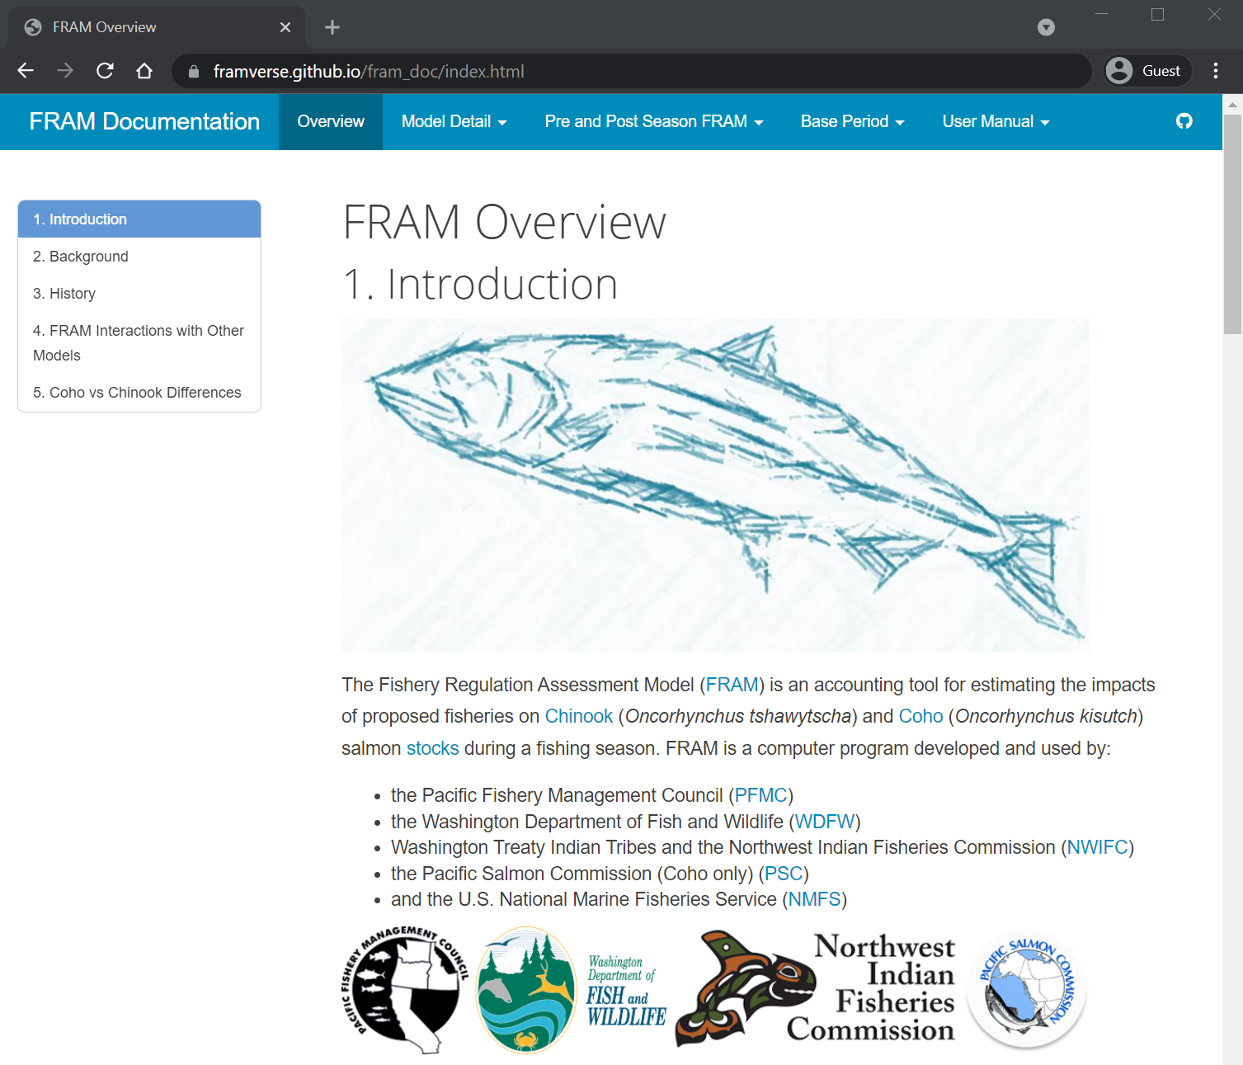

Figure Documentation website landing page

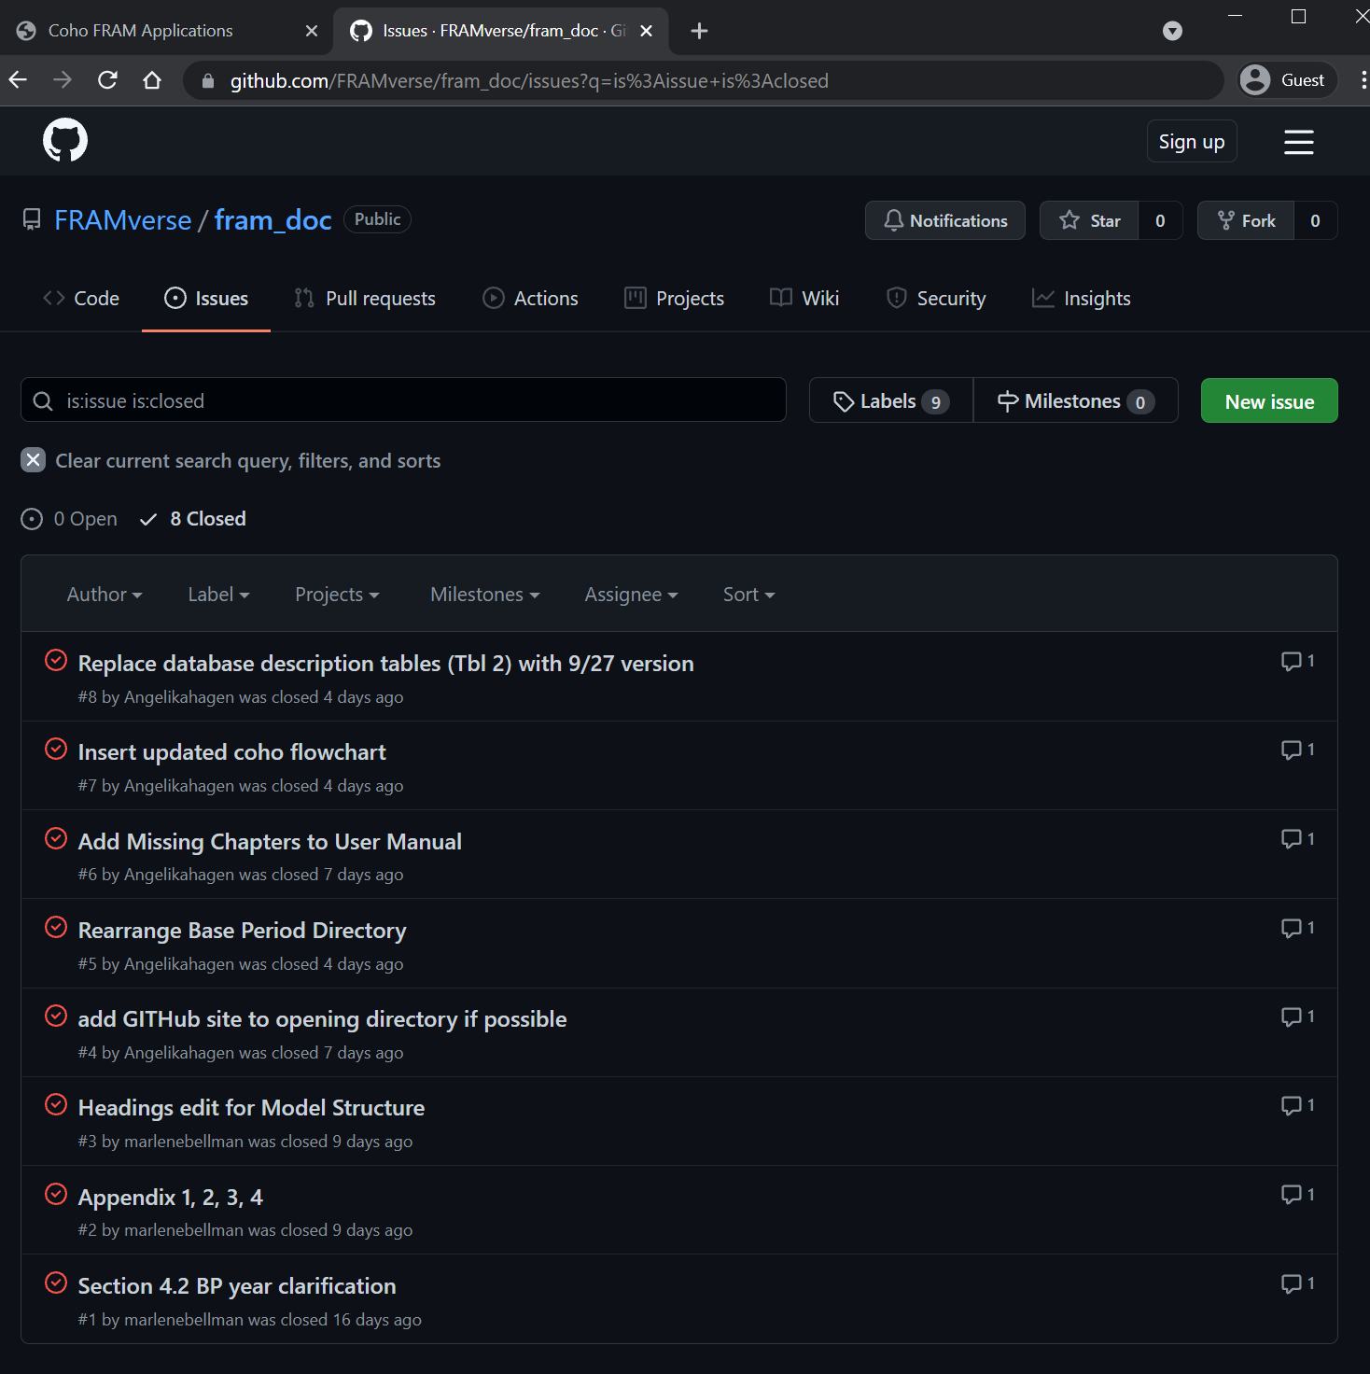

Figure Issue tracking on the source repository provides a convenient means to report, discuss and resolve problems or suggest enhancements.

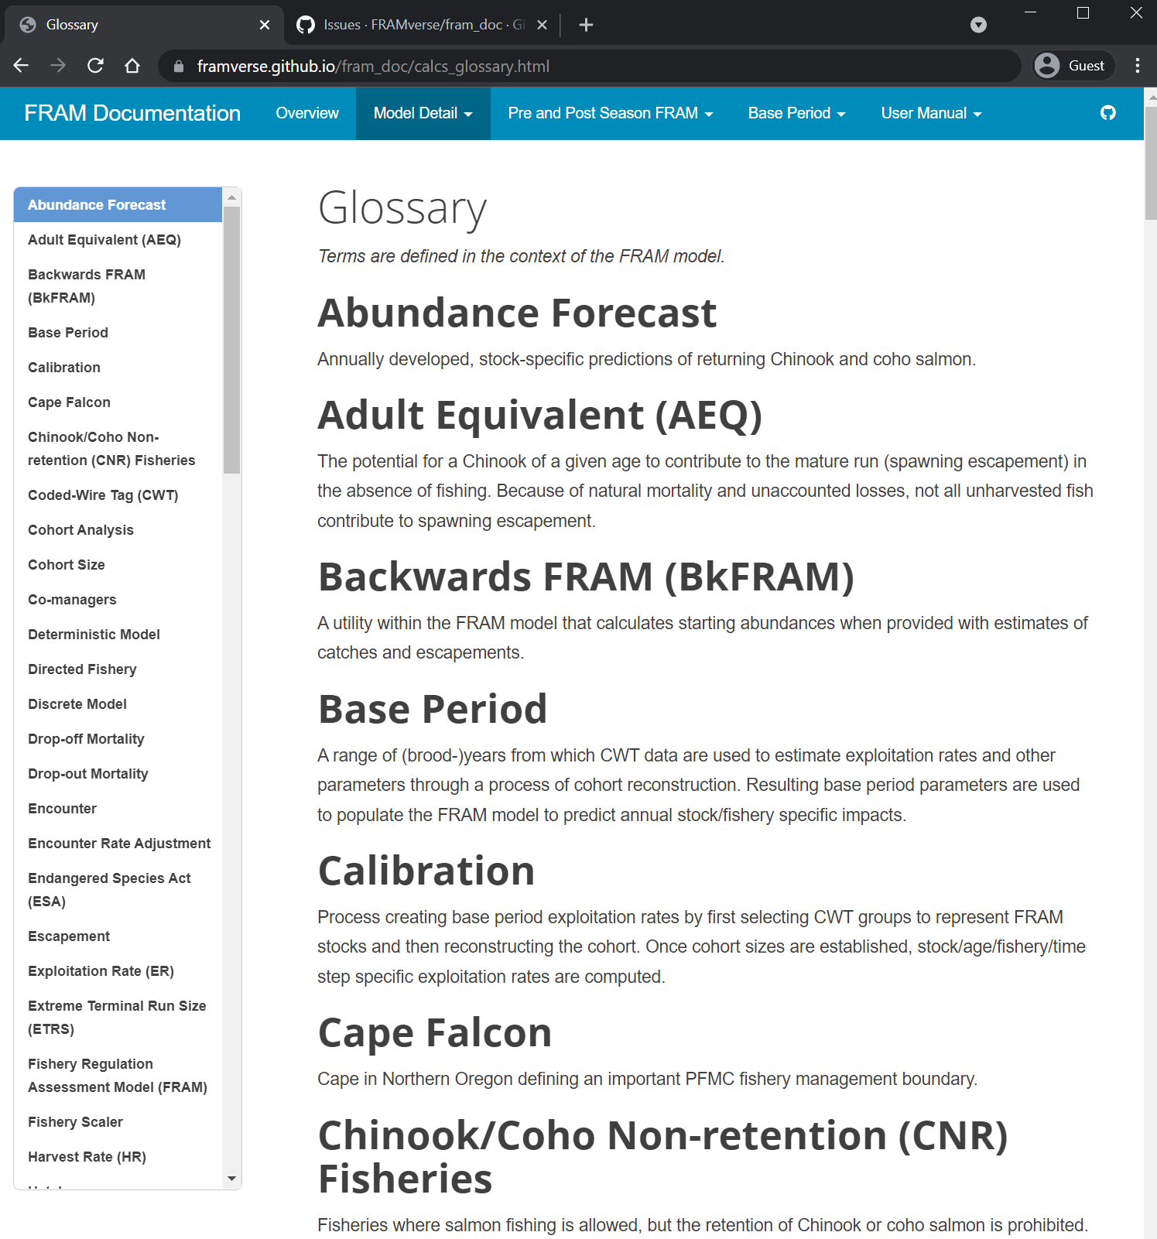

Figure A glossary of specialized terminology is linked to usage throughout the site.

1. While the 2019 version of the User Manual remains available at time of writing, that content has been migrated and integrated into the new site. Staff do not anticipate maintaining the content at <https://wdfw-fp.github.io/framvs_doc/>, and will likely retire this url when the community of practice has gained familiarity with the new, broader documentation site.
2. <https://rmarkdown.rstudio.com/index.html>